Assignment 2

Instructions: Please type the answer in Arial font and paste the codes in Courier font – all in a single PDF document. You must type all the answers and copy paste the code from workbench and submit the completed PDF on dropbox (e-learn). Do not forget to push the final SQL script to your github repository and share your github URL in the PDF.

1. Briefly describe the “employees” database that is used in the course. (5)

Database “employees” has eight tables: current_dept_emp , departments, dept_emp, dept_emp_latest_date, dept_manager, employees, salaries and titles.

2. What are the average, minimum, and maximum salaries of male and female employees?

How many male and female employees are listed in the database? Show the SQL script

to retrieve this information from the database along with the answer. (10)

The average salaries of male is 63838.1769, minimum is 38623, maximum is 158220.

The average salaries of female is 63769.6032, minimum is 38786, maximum is 152710.

There are 179973 male employees and 120051 female.

select gender, avg(salary), min(salary), max(salary),count(distinct e.emp_no) as number

from employees e, salaries s

where s.emp_no = e.emp_no

group by gender;

3. How many employees were working for the dept number ‘d007’ between 1985-01-01

and 1991-03-07? Show the SQL script along with the answer. (5)

There are 2781 employees.

select dept_no,count(distinct emp_no)

from dept_emp

where dept_no='d007'

and from_date <='1986-01-01' and to_date >='1991-03-07'

group by dept_no;

4. How many distinct employee numbers do you have in the database? Group the

employees in terms of employee numbers and obtain the average salary for each group.

Show the SQL script and also first 5 rows of the new table. (10)

There are 300024 distinct employee numbers.

select count(distinct emp_no)

from salaries;

select emp_no, avg(salary), count(emp_no)

from salaries

group by emp_no;

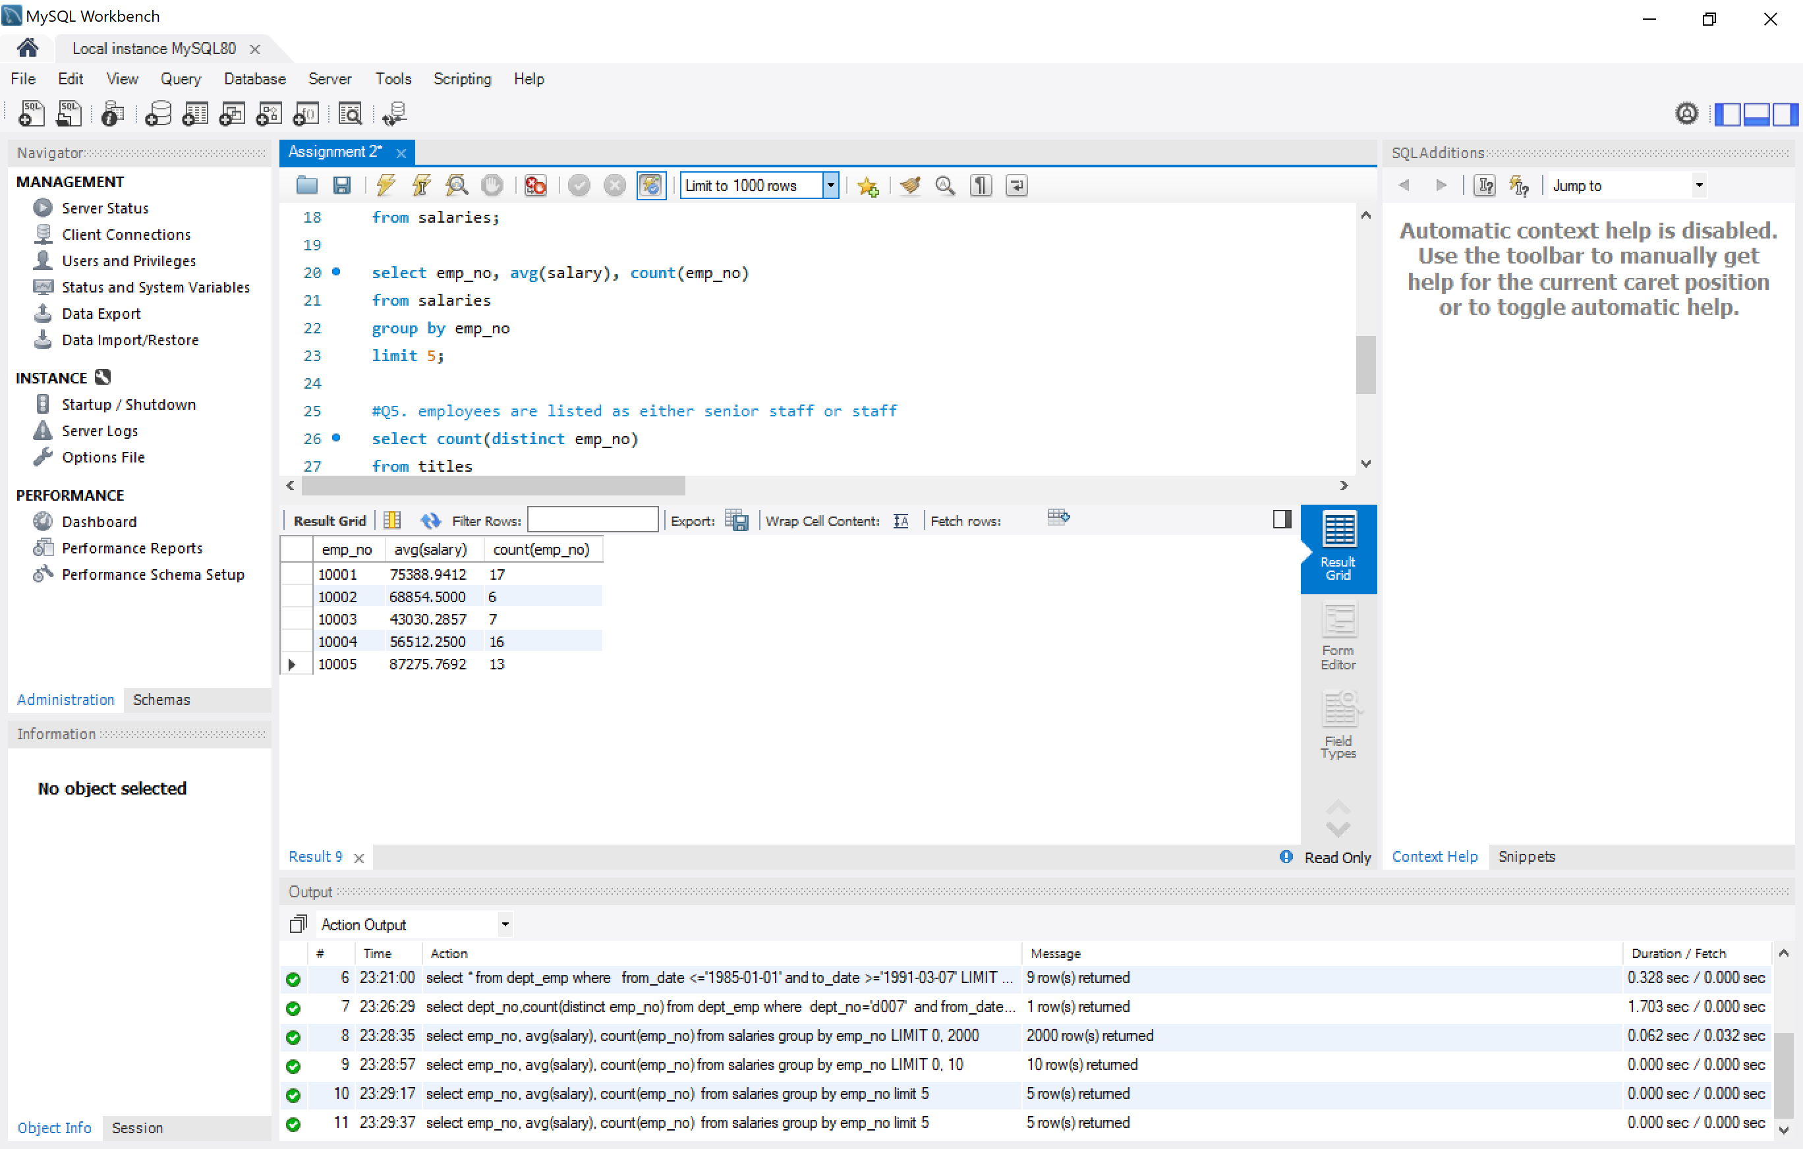

5. How many employees are listed as either senior staff or staff? (5)

133981 employees are listed as either senior staff or staff.

select count(distinct emp_no)

from titles

where title in ('staff', 'senior staff');

6. Push the complete SQL script from mySQL workbench to your git repository and provide

the URL of your SQL script on github. (5)

<https://github.com/LinlinYin/COMP4910.git>